Delph Community Association
Minutes of the Annual General Meeting held on 9th October 2017
Present: Phillida Shipp(PS), Gill Clark(GC), Pat Howard(PH), Janet Curwell(JKC), John Mustoe(JM), Keith Begley(KB), Graham Griffiths(GG), Sue Lund(SL),Janet Reid(JR),Lynne Davies Capper(LDC), Alastair Watts(AW), and Jo Green(JG)
Apologies: Mike Clegg(MC),Geoff Bayley(GB), Maurice Reid(MR)
Minutes of the last AGM on 27th September 2016 were accepted as a correct.
Matters arising:
- Chairman’s Report
See Attached
Comments.
Coop The local Manager has asked that we give feedback on good service to head office either as a group or individually.
Remembrance event. PS will organise this for Saturday 11th November @ 4pm.
She will ask John Rosedale to officiate. GG to ask someone from Delph Youth Band to play the last post.
- Treasurers Report and annual accounts
See attached
The Accounts have been scrutinised by an external examiner Peter Smallwood and have been passed as correct. He is retiring from this position. GG to ask Matthew Bowker if he will take over the checking.
JKC to send letter of thanks to Peter Smallwood.
- Election of Officers
Chair No candidates as yet Nick King and Lynne Davies Capper declined to be chair.
Vice Chair
Keith Begley to continue in the role
Secretary
Janet Curwell to continue in the role
Treasurer
Mike Clegg to continue in the role
Committee: Sue Lund, Pat Howard, Gill Clark, Emily Hughes, Jo Green, Graham Griffiths, Phillida Shipp(as library representative)

- Thank you Phillida
A vote of thanks was given by Graham Griffithst to Phillida Shipp in recognition of her 9 years of committed service as Vice chair and Chair of Delph Community Association. She was presented with a book, a winter planter and a shrub for her garden.
Date and time of next AGM:
25th September 2018 7.45pm Bar Lounge Millgate Arts Centre

DELPH COMMUNITY ASSOCIATION
Chair’s report to the AGM October 2017
Delph Community Association (DCA) has focussed on two main areas this year: supporting Delph Library and maintaining and improving Chapel Garden.
Delph Library
The Library continues to be staffed by volunteers working in partnership with Oldham Libraries. It is open for 20 hours each week. A Library Assistant works alongside volunteers during opening hours. DCA pays for the running costs of the library, but receives a grant from Oldham Council to help with this.
There were 4161 visits to the library in the year July 1st 2016 – June 30th 2017. The computers were used for 262 hours during that period. Two young people have worked as volunteers as part of their Bronze Duke of Edinburgh Award and a third has completed their Gold Award.
Three Reading Groups now use the library:
The ‘Dead Good Read’ group meets on the third Thursday of the month from 2.00 – 3.00pm
The’ Book Club to make Mummies find time to read’ meets on the third Wednesday of the month from 2.30 – 3.00pm
The Library Reading Group meets on the third Thursday of the month from 6.00 – 7.00pm.
The Library also now acts as the box office for Saddleworth Players and Live in Saddleworth. Much of the ticket booking occurs on line but it is also possible to book over the phone (01457 874644) or by visiting the library in person.
There are at present 27 volunteers who help to staff the library. The optimum number is 30. If anyone is interested in becoming a library volunteer they should phone 01457 875171.
Chapel Garden
The generous contributions from ‘Friends of Chapel Garden’ and Delph Co-op have made it possible for DCA to hire a gardener for Chapel Garden. Despite this year’s uncertain summer, Danny our gardener has managed to mow the lawns, albeit sometimes in the rain and consequently they have not received a close cut.
Keith has continued to increase the number of perennials in the flowerbed and reduce the annuals. The money saved could be used to buy more shrubs in future. The kerbstones around many of the graves have been removed to facilitate mowing. Turf may become available to replace the grave mounds, if not they will be seeded. Volunteers may be needed to assist in clearing the leaf fall in mid November. Danny has offered to help construct a compost area along the inside of the west wall adjacent to the car park. In late October, it is planned to plant two memorial spring flowering cherry trees, inside the north wall adjacent to the river.

Fund Raising
Scarecrow Trail: This year’s theme was Musicals. There was a wonderful variety among the scarecrows, ranging from My Fair Lady and Carousel to Annie and Frozen. Many people followed the trail over the two weeks, which started with the half term holiday and ended after the Whit Friday weekend. £650 was raised.
The winner of the draw for the correct answers was Julie Bradbury from Mossley who won the £50 voucher for a meal at the Old Bell Inn. Other prizes were donated by the Bay Leaf Restaurant, Saddleworth Players, Shear Perfection and Di Gaunt. The cup for the favourite scarecrow chosen by those who purchased trail guides went to the Old Bell for their depiction of Mama Mia. A close second was the Wizard of Oz made by Jose Whitehead and her daughter Susan. The DCA Artistic and Creative Merit award went to Jill Davis and members of the Methodist Church for their version of Top Hat.
Thanks to all those who took part, including the scarecrow makers, the prize givers, Di Gaunt and Jake Geen for composing the trail booklet, and David Cummins for printing it. Particular thanks are due to Sue Lund who organised the whole venture.
Theatre Evening: This year we shared the event with Delph Senior Citzens. Many thanks are due to to those who sold tickets, who provided the supper, and also of course to Saddleworth Players who donated the theatre tickets. £361 was raised.
The Friends of Chapel Garden: A magnificent sum of £1459 was donated by local friends this year. It is great that so many local people support DCA in this way and agree that Chapel Garden should be maintained as an asset for the community.
The Co-op Local Community Fund: DCA are also very grateful to Delph Co-op who have chosen us as one of their local charities. We have received £886 from them this financial year. Particular thanks are due to Julie and Darren.
Santa’s Grotto: This was held on December 17th and was an enjoyable occasion. Keith’s Grotto was much admired and Graham was a convincing Santa. It is hoped to hold the event this year on the afternoon that the Christmas lights are turned on in the village.
Beautiful Delph
Jo Green has organised a series of planting, weeding and litter picking events in the village at monthly intervals throughout the year. Hopefully this has led to a greater awareness of the beauty of our village. Thanks are due to Jo for providing tools and enthusiasm and to a stalwart band of helpers who turn out in all weathers. The next Village Clean Up will be on Saturday November 25th 10.00 – 12 midday.
There is also a rota of litter pickers who take it in turn to keep Chapel Garden, the car park behind the Methodist church, and the Swan Meadow Play Area free of litter. Many thanks are due to them. Anyone interested in joining the rota should phone 01457 875171.

Whit Friday Sports
These were held on Delph School playing field on Whit Friday afternoon. Although the ground was a bit wet both children and adults had a good time. Thanks to all the volunteers who started the races and identified the winners, and also to Delph School for allowing us to use their field and equipment.

Above and Beyond Award
This is a Saddleworth wide scheme devised by Ken Bennett and supported by the Saddleworth and Lees District Partnership. Each village was asked to choose someone who they thought had gone above and beyond the normal call of duty to help others and their community. DCA organised leaflets and publicity encouraging as many people as possible to vote. The Executive Committee received the nominations and counted the votes. Ella Wellman was the winner and received her greatly deserved award at a celebratory supper organised by Delph Senior Citizens Committee.
Communications
Emily Hughes has set up a Facebook Page for DCA, is running it, and has also devised a logo for us. It is hoped that this will raise DCA’s profile among Delphers and thus increase our membership. Please like the page! Many thanks to Emily for her help.
We are also in the process of acquiring a new web site. The address will remain the same: www.delph.org.uk but it should be easier to use than the old one.
Remembrance Ceremony
For the past few years DCA has organised a small ceremony at the three war graves in the graveyard of the former Independent Methodist Chapel. In November 2016 the Methodist Minister led the service, and Spike, from Delph Training Band, played the last post. The ceremony was attended by 21 people including Maurice Whitehead’s sister, who laid a wreath on his grave. It is intended to hold a similar ceremony this year.
Thanks: to all those who have attended our meetings and taken part in our activities. This includes special thanks to all Delph Library Volunteers. Thanks also to the Millgate Arts Centre and Delph Library for allowing us to meet in their buildings. Particular thanks go to Janet Curwell, Mike Clegg, Keith Begley, Gill Clark, Sue Lund, Pat Howard, Geoff Bayley, Graham Griffiths, Jo Green and Emily Hughes.
Phillida Shipp
October 2017

Treasurers Report
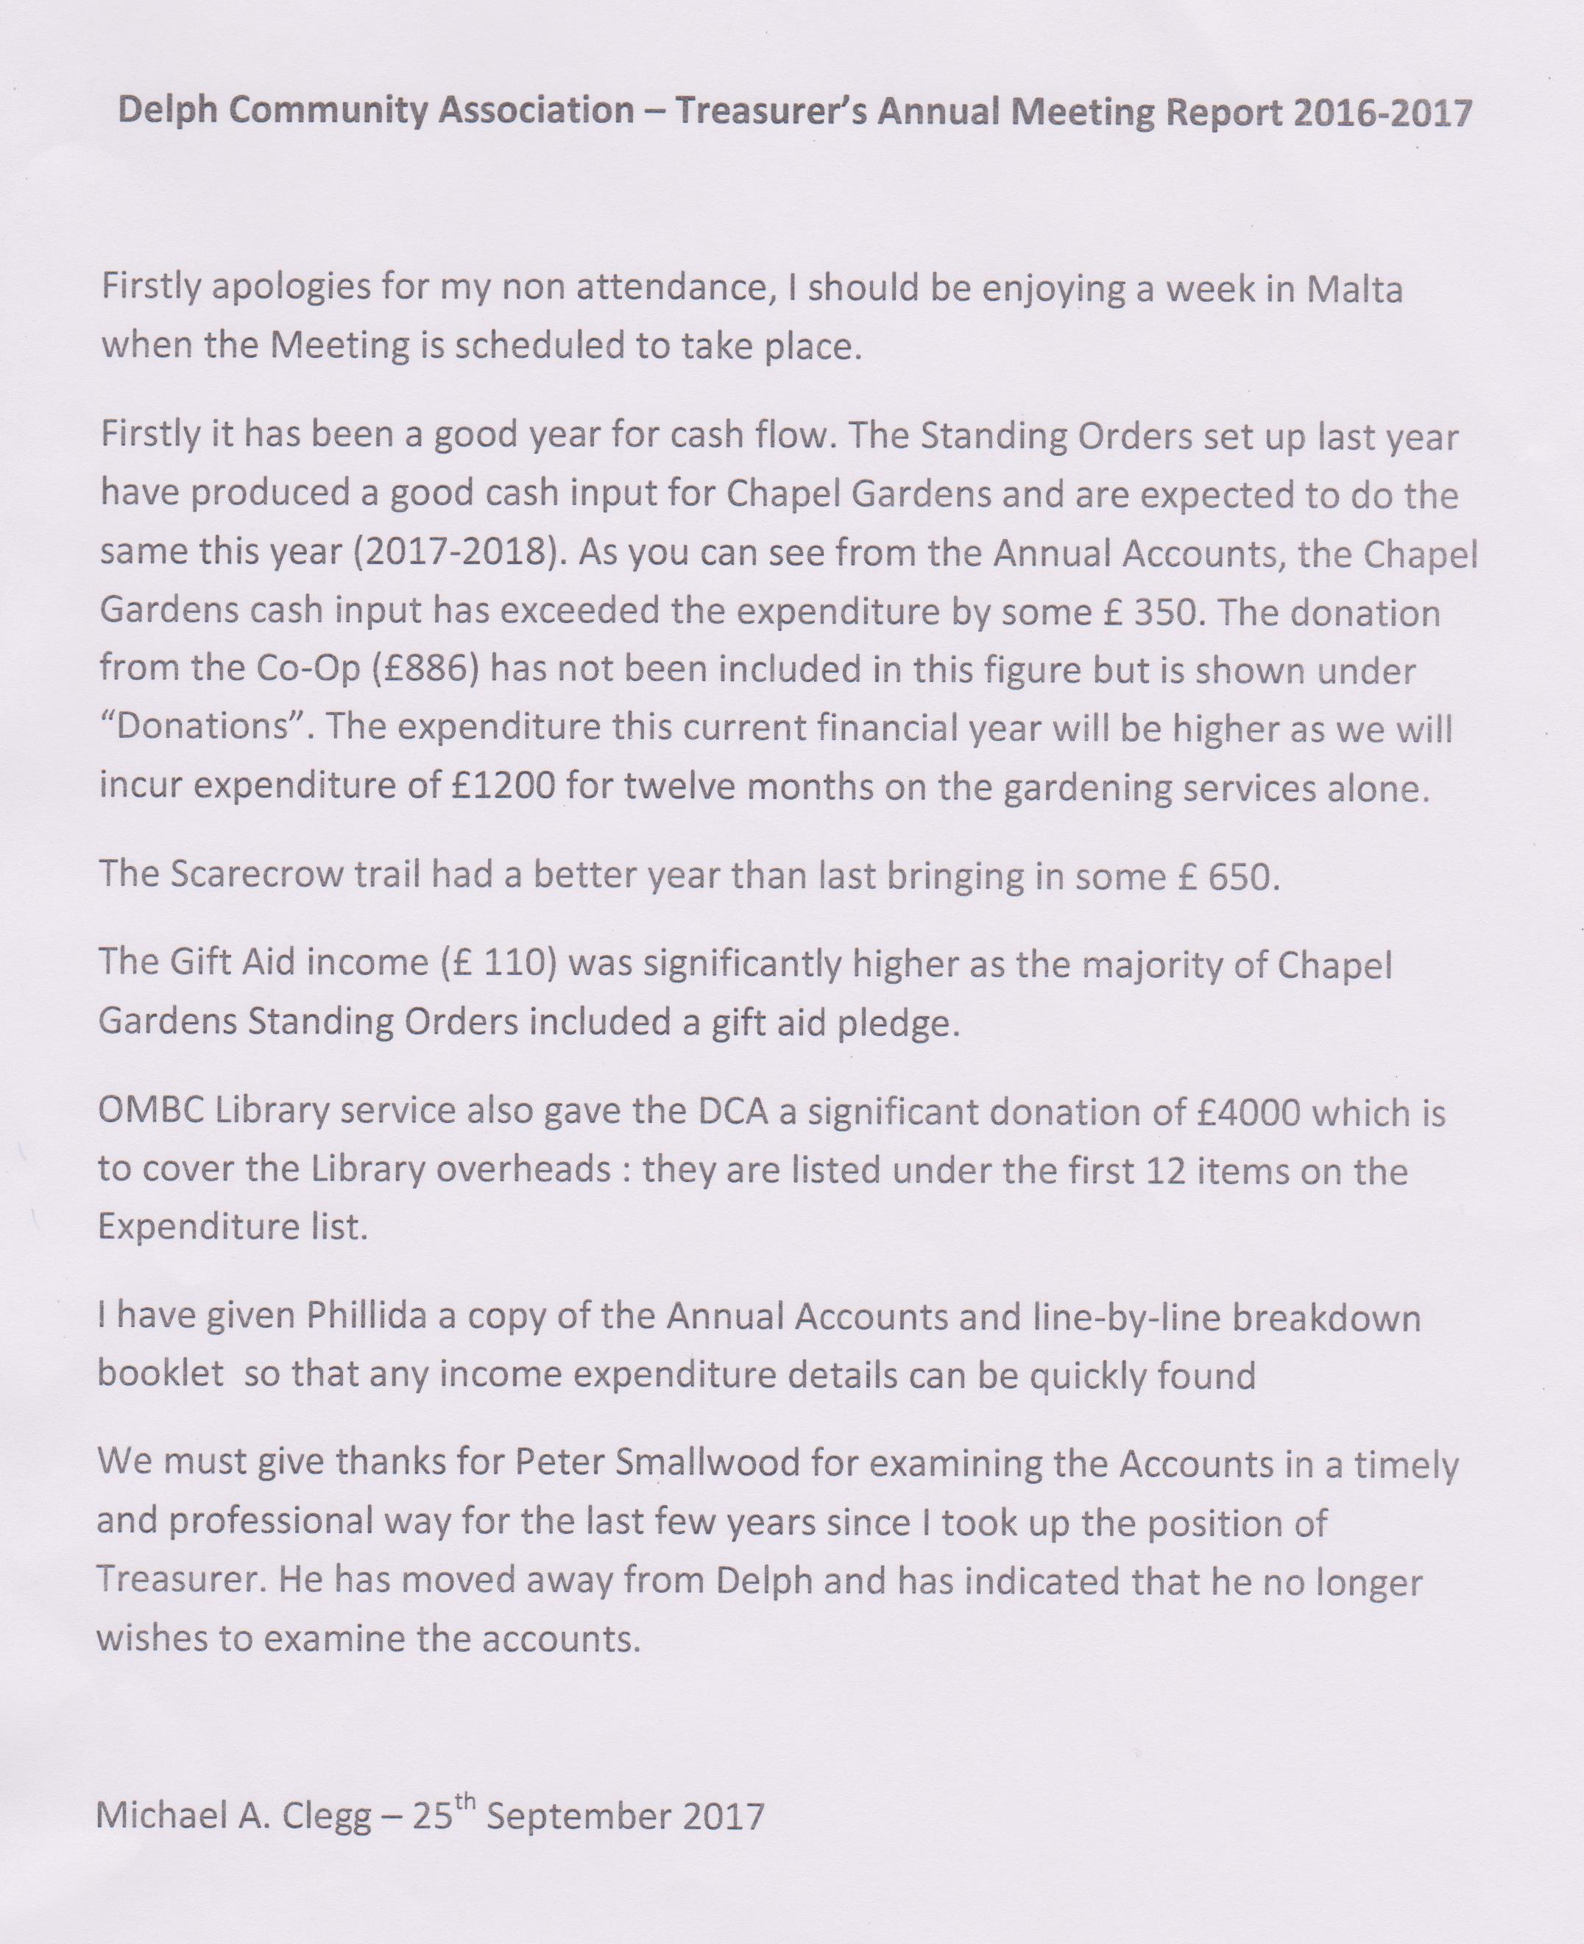

Accounts
